**How to start your project (I)**

**Objectives:**

1. Meet with your supervisor to discuss a project.
2. Define project goals and objectives.
3. Review and make a list of relevant literature and conduct research. Identify necessary resources.

**Summary of weekly activities**

* Contact with my supervisor through WhatApps to have a discussion on the topics including the AI Manhole Detection System
* Find some resources about manhole detection to identify the objectives of doing this project
* Make some research on the AI machine vision process

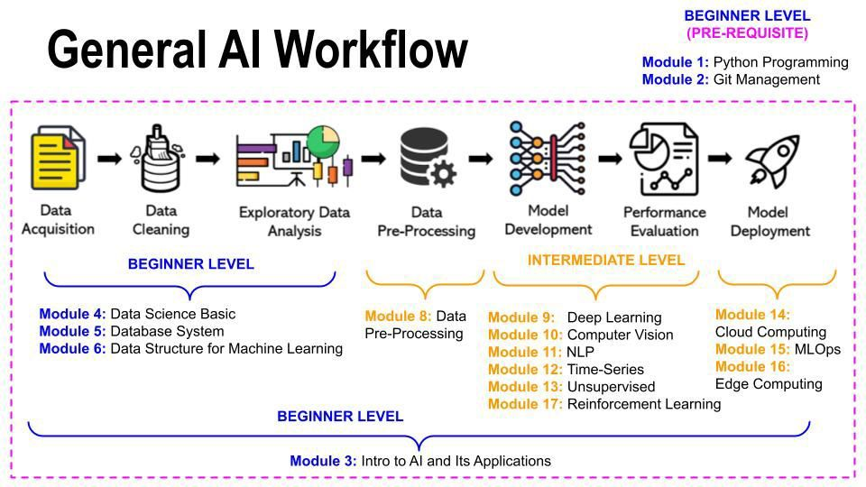

**Summary of weekly activities**